Oyster Task Force Minutes
Tuesday, October 11, 2022, 1:00 p.m.
Jean Lafitte Civic Center
4953 City Park Dr.
Lafitte, LA 70067

I. Pledge of Allegiance
II. Roll call and introduction of guests

Voting Members Present:
Jakov Jurisic
Mitch Jurisich
Brad Robin
Sam Slavich
Peter Vujnovich
Steve Pollock

Voting Members Absent:
Shane Bagala
Tracy Collins
Dan Coulon
Al Sunseri
Matthew Slavich
Brandt Lafrance
Willie Daisy

Non-Voting Members Present:
Carolina Bourque
Justin Gremillion
Harry Vorhoff

Non-Voting Members Absent:
Major Edward Skena
Karl Morgan
Brian Lezina

III. Peter Vujnovich motioned to approve the September 20, 2022 draft meeting minutes, 2nd by Jakov Jurisic. Motion carries.

Jakov Jurisic motioned to postpone item E. To Hear an Update on the 2021 Oyster Mortality Event in the Empire/ Port Sulphur Area, to a meeting at a later date, 2nd by Peter Vujnovich. Motion carries.

Peter Vujnovich motioned to approve the agenda as amended, 2nd by Jakov Jurisic. Motion carries.

IV. Treasury Report
Remaining Fund Balance- $577,794
Remaining Budget Balance- $67,462
Tag Sales through September- 448,800
Jakov Jurisic motioned to approve the Treasury Report as presented, 2nd by Peter Vujnovich. Motion carries.

V. Committee Reports

- Public-Private Oyster Seed Grounds Committee- no report
- Enforcement Report-

September 18th- October 2nd
Region 4 (Iberia)
None

Region 5 (Calcasieu and Cameron)
None

Region 6: (Terrebonne, Lafourche, Grand Isle)
Terrebonne
2- Violate Sanitation Code (Refrigeration)
2-Violate Sanitation Code (Deck Top)
2-Violate Sanitation Code (Logbook)
4- Harvest oysters illegal hours
4- Fail to cull oyster in proper location
1-Fail to have commercial license in possession
1-No commercial gear license
64 sacks were seized

Region 8: (Jefferson, Plaquemines, St. Bernard, Orleans)
Plaquemines
1-Sanitation code-Log Book
1-Failure to fill out oyster tags correctly
1-No Vessel license
11 Sacks Seized

St. Bernard
1-Sell without wholesale/retail license
1-Fail to maintain records
1-Fail to fill out trip tickets
1-Sanitation code-Refrigeration
18 sacks seized

- Legislative Report- no report
- Legal Report- no report
- Research Report- no report
- Coastal Restoration Report- no report
- Marketing Report- OTF commercial almost finished running, it has been a good campaign, would possibly look into doing it again in the future, no Seafood Promotion and Marketing Board news or meetings will keep the board updated when a meeting is set
- Health Committee Report- Justin Gremillion stated that at the last meeting LDH was approached about expanding some of the lines in the Point-aux-Chenes area, have since added two more sampling points in the area to see if they can get some good samples and shift the line, may take some time for the samples to come in; Map showing set for 10/12/22 at the Jefferson Parish Health Unit on the east bank from 10am-12pm
John-Zach Lea suggested that the OTF consider modernizing on relay
- Aquaculture Committee Report
Steve Pollock stated that LOAA will meet soon and plans to submit a letter to the Corps opposing the Mid-Barataria Sediment Diversion; the Aquaculture Committee plans to discuss bond removals on large equipment at a future committee meeting
- Joint Task Force Working Group- held a meeting in Belle Chasse on 10/5/22; a little disappointed in the turnout, the crab and finfish task forces could not make it, came up with the consensus that all task forces oppose the Mid-Barataria Sediment Diversion and plan to do a joint letter from all the task forces opposing the Corp approving the permit, asked everyone else to do the same, this is a final EIS, it’s done this is the final the comments should be opposing the issuance of the permit for the project
Jakov Jurisic motioned to approve the committee report and send a Joint Task Force Working Group letter to the Corps of Engineers opposing the issuance of the permit for the Mid-Barataria Sediment Diversion Project, 2nd by Brad Robin. Motion carries.
Peter Vujonich asked that all board members urge their organizations and the industry to submit letters as well
- Carolina Bourque provided a reminder on the oyster season rules
Additional Oyster Season Regulations:
- Every Vessel harvesting market-size oysters from the Public Oyster Areas shall report harvest information to the LDWF before 9pm each day fished.
- Vessel shall provide the following information: Captain’s name, oyster harvesters’ number, boat number, the total number of full-sized sacks harvested that day, and the public oyster area fished.
- Call 1-800-442-2511 or send email to oyster@wlf.la.gov to submit harvest reports. This reporting does not substitute for trip ticket reporting.
If you have already purchased the $50 retention fee, this is not your permit you will need to purchase a scraper license to be able to fish in the public areas, can renew your license in person in Baton Rouge, by email, or over the phone
Carolina stated that beautiful spat set is being seen all throughout the state
Mitch Jurisich asked Carolina to monitor this very closely and if there is availability to open a special season east of the River, south of the MRGO, these favorable conditions are due to the low river,
Brad Robin stated that this is a good time to turn over areas while we have the best recruitment we have seen in years
Carolina state that Drum Bay Cultch Plant has seen some spat set not as much as Vermillion but they are seeing improvements
- Mitch Jurisich led discussion on the OTF submitting comment on the final EIS for the Mid-Barataria Sediment Diversion
Jakov Jurisic motioned to write a letter to the Corps of Engineers requesting an extension of the comment period deadline, 2nd by Peter Vujnovich. Motion carries.
Mitch Jurisich stated that Plaquemines parish will be voting on Thursday to send another letter in opposing the final EIS
Brad Robin motioned to submit an Oyster Task Force comment opposing the issuance of a permit for the Mid-Barataria Sediment Diversion project, 2nd by Sam Slavich. Motion carries.
The board discussed the possibility of hosting an industry demonstration at the Capitol to oppose diversion, need to look into logistics of transportation, would like to look into the possibility of OTF funding transportation to the Capitol; also discussed getting a small committee together to meet with the Corps of Engineers in Vicksburg in mid-November, Plaquemines Parish Government wants to be involved, Brad Robin stated that St. Bernard would like to be involved, would also like to get Jefferson Parish involved, Jakov Jurisic stated that he would reach out to the Lt. Governor to see if he will get involved; BMF to reach out to the Corps on behalf of the industry to try and set up a meeting will get back to the task force with possible dates
- The Aims Group provided a presentation on the St. Bernard Ridge Project
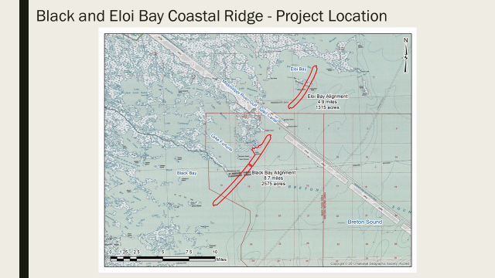
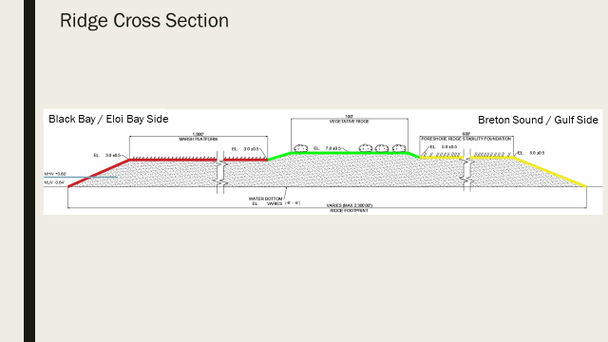
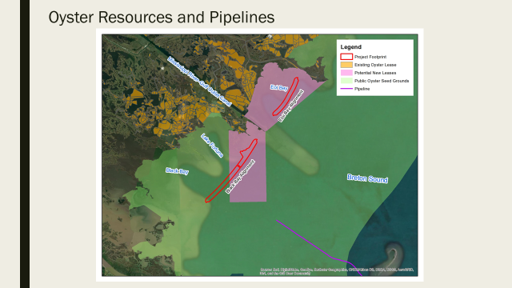
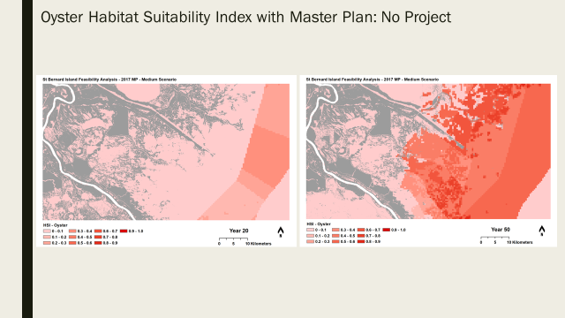
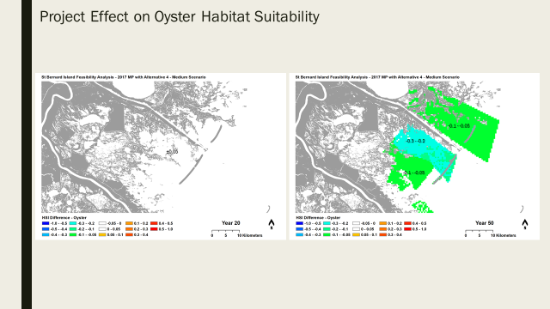
St. Bernard Parish funded project, the highest ridge is about 7ft and the cost is approximately $171,000,000

Carolina Bourque stated that the area proposed is right on the undesignated seed grounds where extensive work has been done to make sure we get a seed grounds that will be productive once the moratorium passes so there are some issues

Peter Vujnovich stated that this project will not help with the productivity of oyster fishermen at all, see it as a possible liability

Sam Slavich asked if they have a sense of sand migration. Concern with where the sand will move to; the Aims Group stated that they will have more answers after this phase, also would like to know if the plan includes LDWF mitigation for the loss of oyster grounds

18 months is the time frame to complete the project

Tony Tesvich stated that he opposes the location and feels the money could be better spent reinforcing existing shoreline

The task force asked that the Aims Group keep the Oyster Task Force and industry informed on the project as it progresses

- The task force considered 2023 ISSC proposals

The board has until November 18, 2022 to submit proposals; would like to submit a proposal related to time/temperature requirement on green tags take it from 8hrs back to 16 hours to refrigeration; LDH stated that they would not be opposed to this

Jakov Jurisic motioned to submit an ISSC proposal to change the time/ temperature regulations on green tags from 8 hours back to the original time/temperature regulations, 2nd by Peter Vujnovich. Motion carries.

Brad Robin motioned to submit an ISSC proposal to change from 1 hour program to 5 hours to refrigeration on white tags, 2nd by Jakov Jurisic. Motion carries.

Justin Gremillion stated that the white tag proposal may take more work to get support on, may be a little difficult to pass; Justin Gremillion stated that he will get the data on the tags compiled for the OTF to submit proposals, will have the data by the next meeting

The OTF plans to host a Health Committee meeting prior to the next OTF meeting to discuss ISSC proposals

The chairman went back to item B. To Consider Submitting Oyster Task Force Comment on the Final EIS for the Mid-Barataria Sediment Diversion at this time

Jakov Jurisic motioned to request that LDWF submit a comment on the final EIS for the Mid-Barataria Sediment Diversion, 2nd by Brad Robin. Motion carries.

- The board discussed the Corps plan for Neptune Pass

Mitch Jurisich led discussion stated that the pass is now about 300ft wide and 80ft deep, the Corps plan is to not to completely close Neptune Pass, they plan to close it but leave a 100ft wide and 12 foot deep gap continuously running through, it makes no sense not to have a complete closure because you are building a 12ft sill in 8ft of water, the sediment is going to be low in the water column and it’s not going to pass the sill, so it’s not going to be a ‘sediment diversion’. Would like to request that BMF draft a letter to the Corps to request a complete closure of Neptune Pass. Also had the article come out on this and maybe we can do a letter to the editor or a response on this to request a complete closure

Brad Robin motioned to write a letter to the Corp of Engineers to request a complete closure of Neptune Pass, 2nd by Peter Vujnovich. Motion carries.

Brad Robin motioned to request that LDWF submit a letter requesting a complete closure of Neptune Pass to the Corps of Engineers, 2nd by Peter Vujnovich. Motion carries.

VII. Public Comment

Haley Gambill introduced herself to the task force as the new agent with LA Sea Grant

VIII. Next Oyster Task Force meeting set for Tuesday, November 15, 2022 for 1pm in Baton Rouge. Health Committee Meeting prior for 10am followed by an Aquaculture Committee meeting for 11am.

IX. Jakov Jurisic motioned to adjourn, 2nd by Peter Vujnovich. Motion carries.

